Ideation Phase
Define the Problem Statements

Date | 01-July-2026
Team ID
Project Name | Cosmetic Insights: Navigating Cosmetics Trends and Consumer Insights with Tableau
Maximum Marks | 2 Marks

Customer Problem Statement Template
Create a problem statement to understand your customer's point of view. The Customer Problem Statement template helps you focus on what matters to create experiences people will love.
A well-articulated customer problem statement allows you and your team to find the ideal solution for the challenges your customers face. Throughout the process, you’ll also be able to empathise with your customers, which helps you better understand how they perceive your product or service.
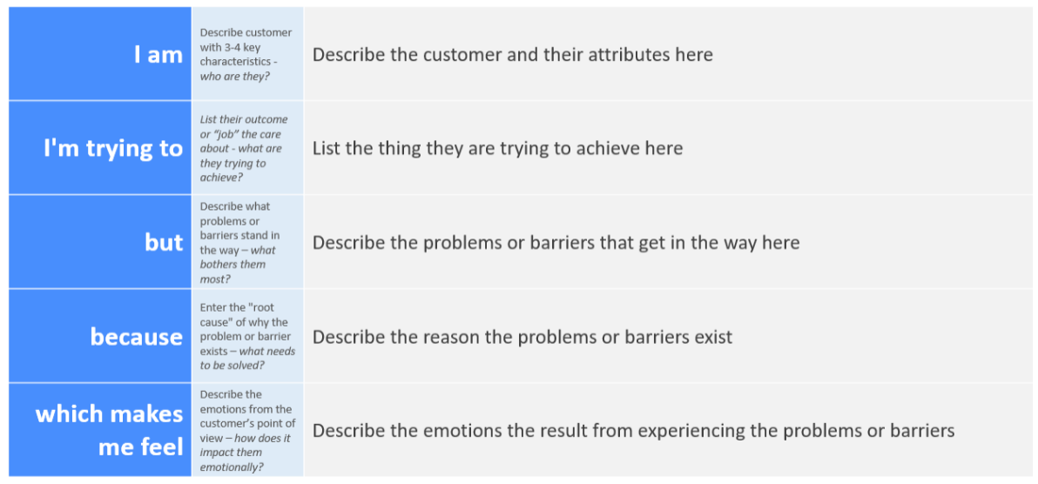
Reference: https://miro.com/templates/customer-problem-statement/
Example:
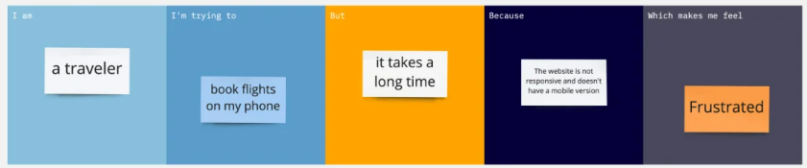
Problem Statement (PS) | I am (Customer) | I’m trying to | But | Because | Which makes me feel
PS-1 | An online shopper | Return a pair of shoes that do not fit | I cannot fine a return shipping label anywhere on the website | The digital return portal requires contacting customer service first | Annoyed and trapped
PS-2 | A patient tracking a chronic condition | Log my daily medication dose | The logging process takes too many taps and screen transitions | The interface requires manual data entry instead of quick presets | Overwhelmed and discouraged

